play_btn.addEventListener(*"click"* , () =>{

   cancion.play();

   cover.style.animationPlayState=*"running"*;

   controls.style.animationPlayState=*"running"*;

});

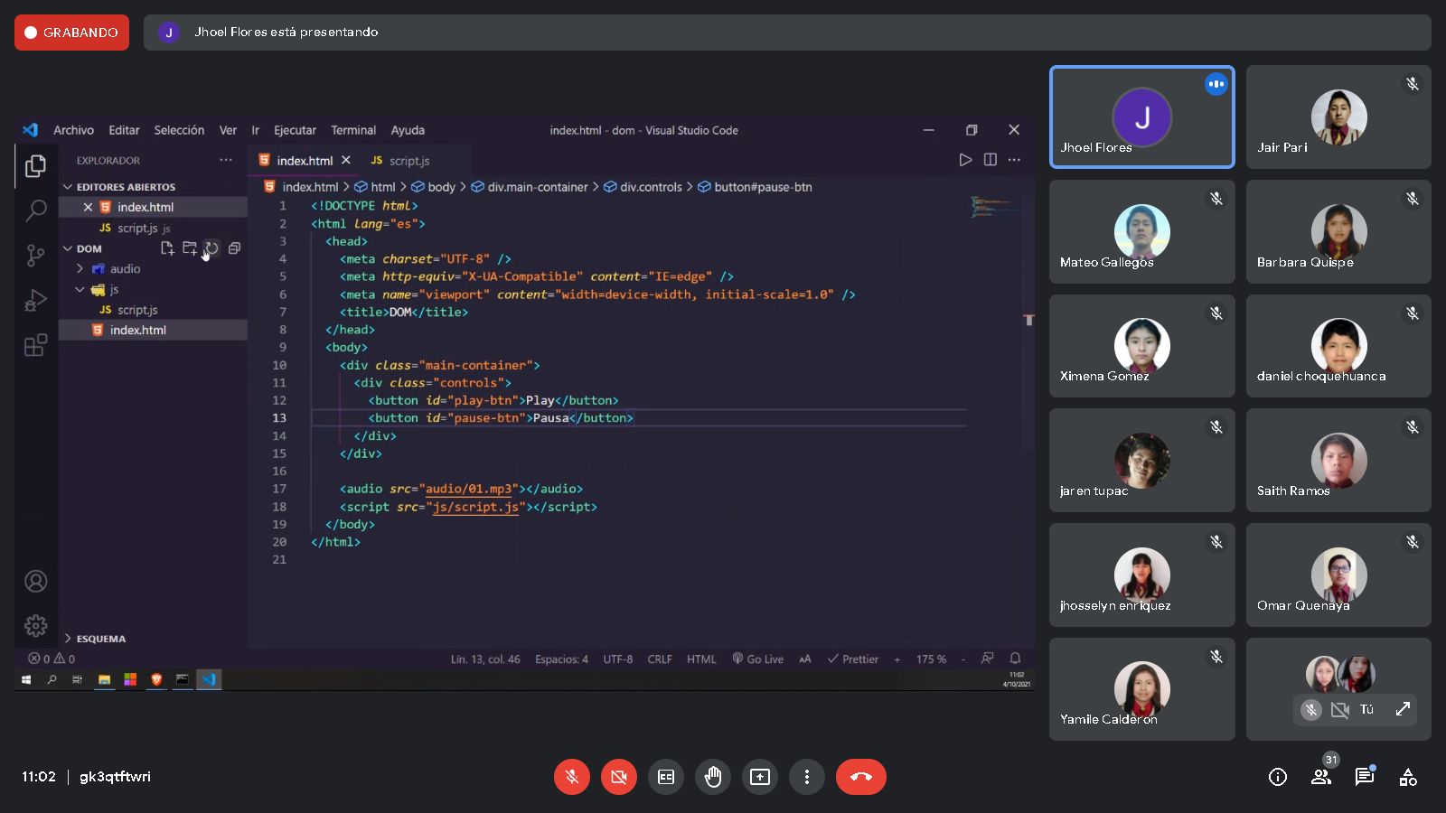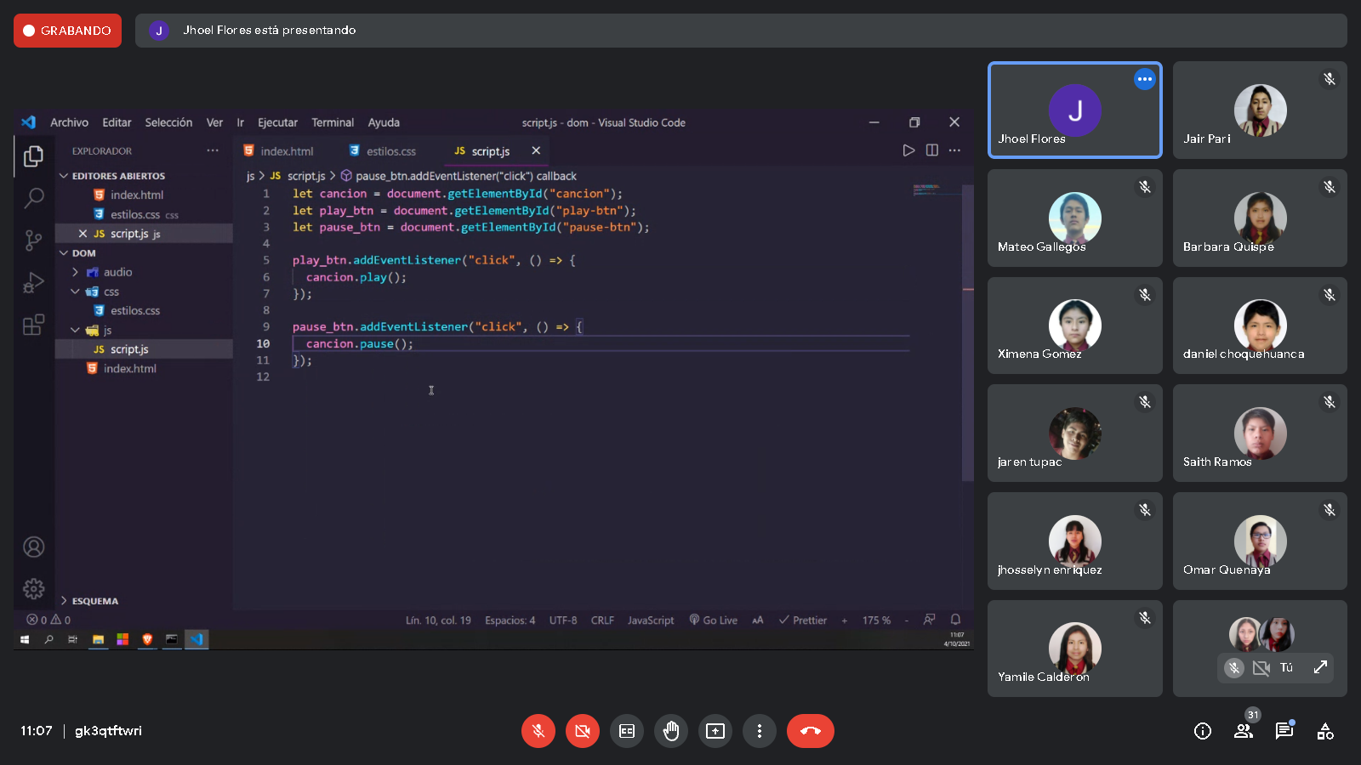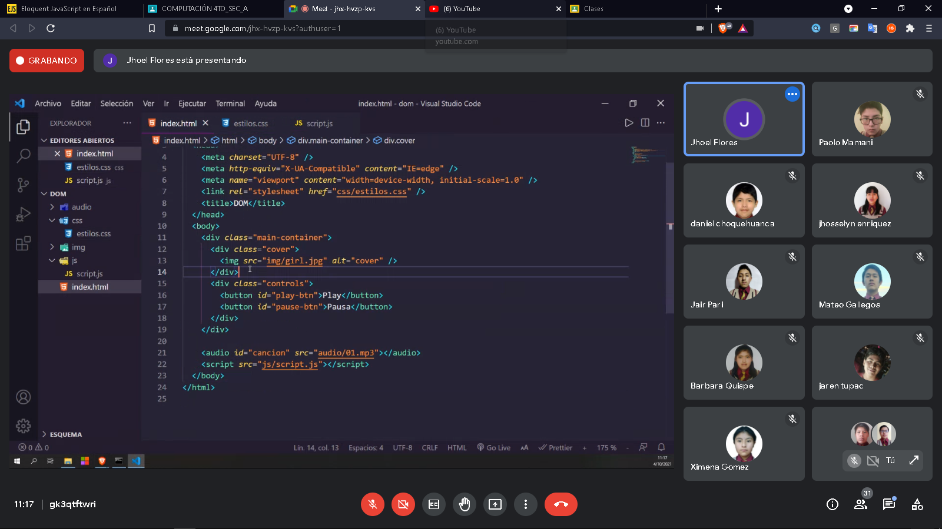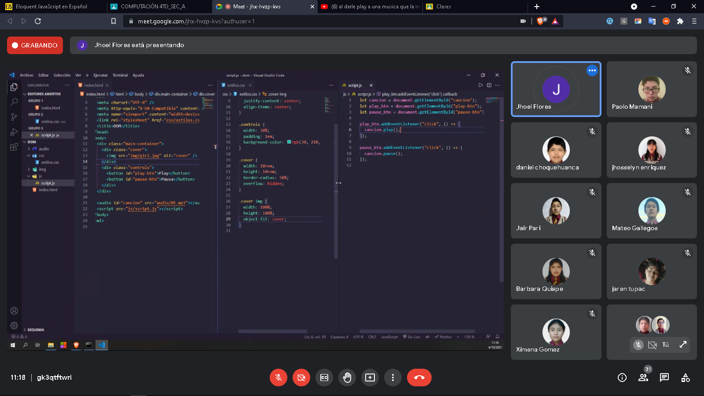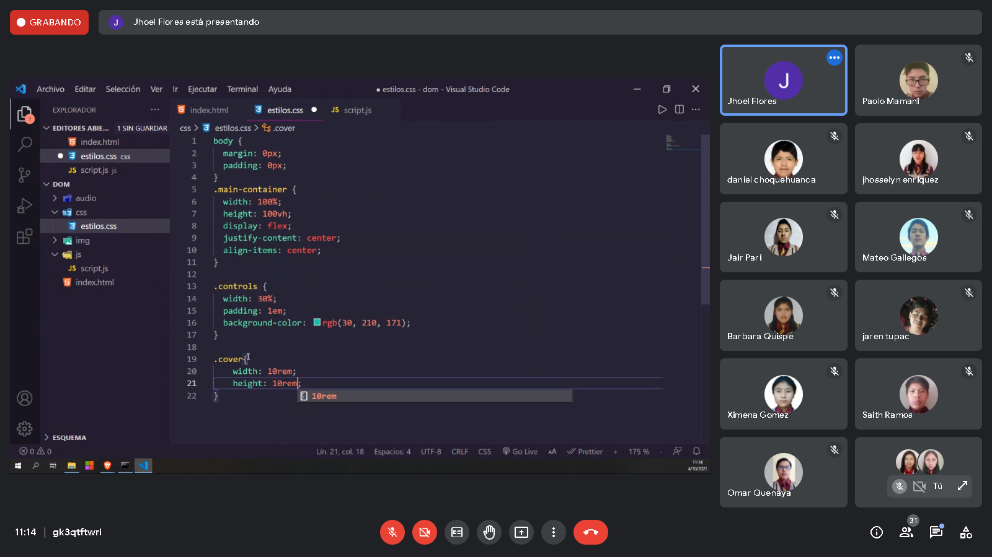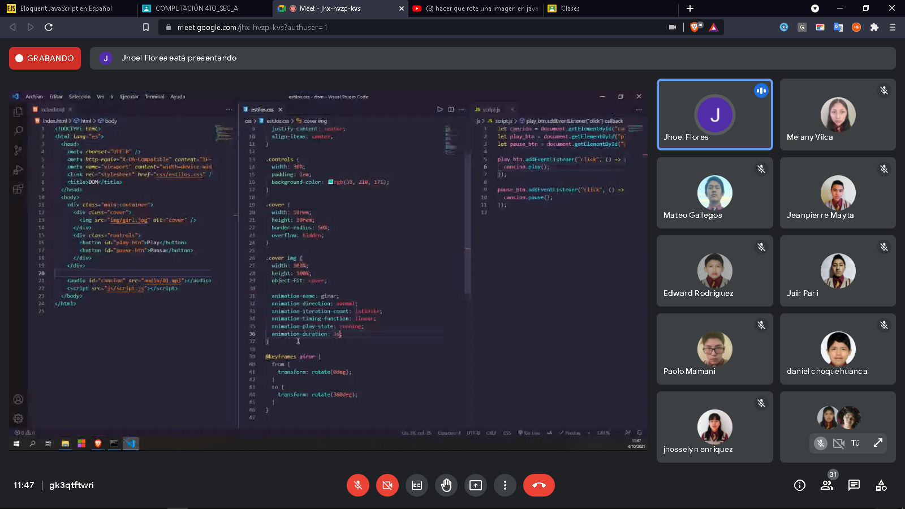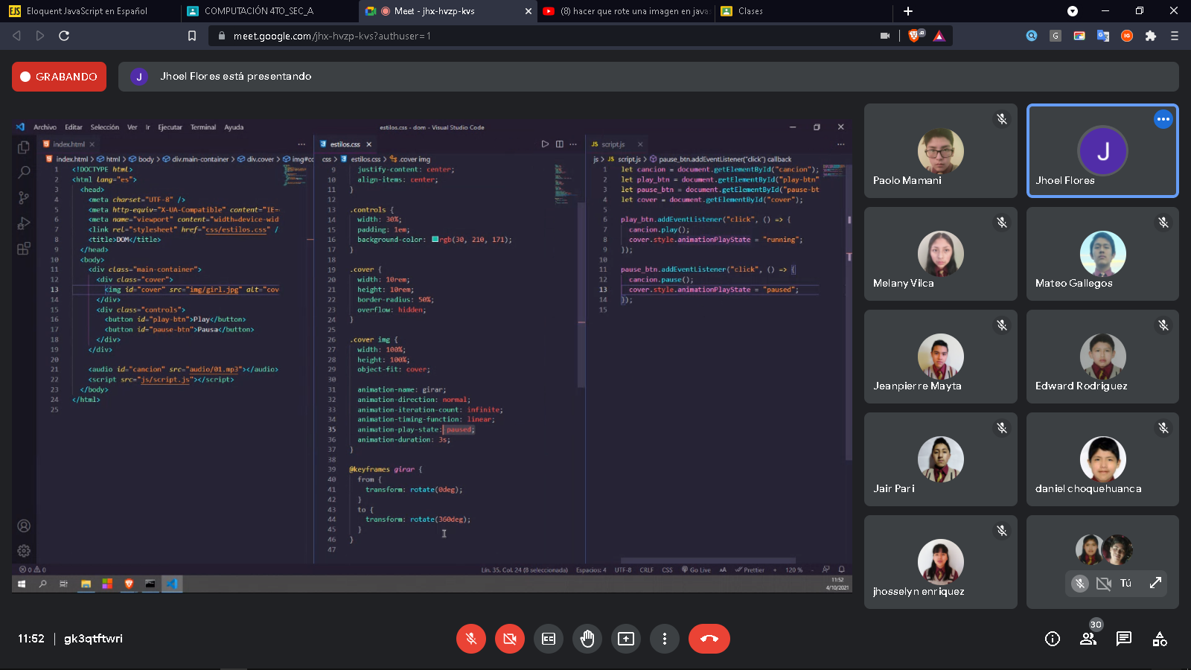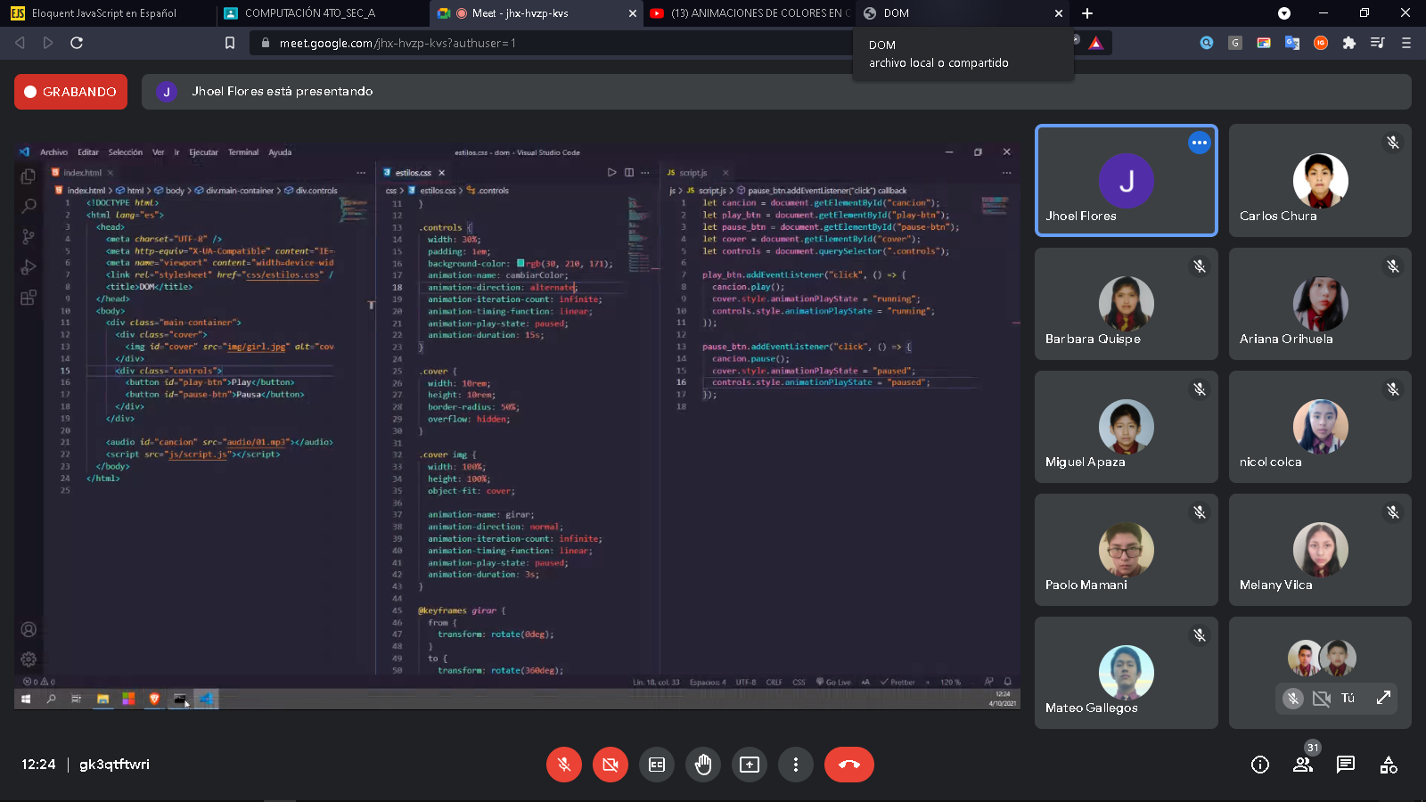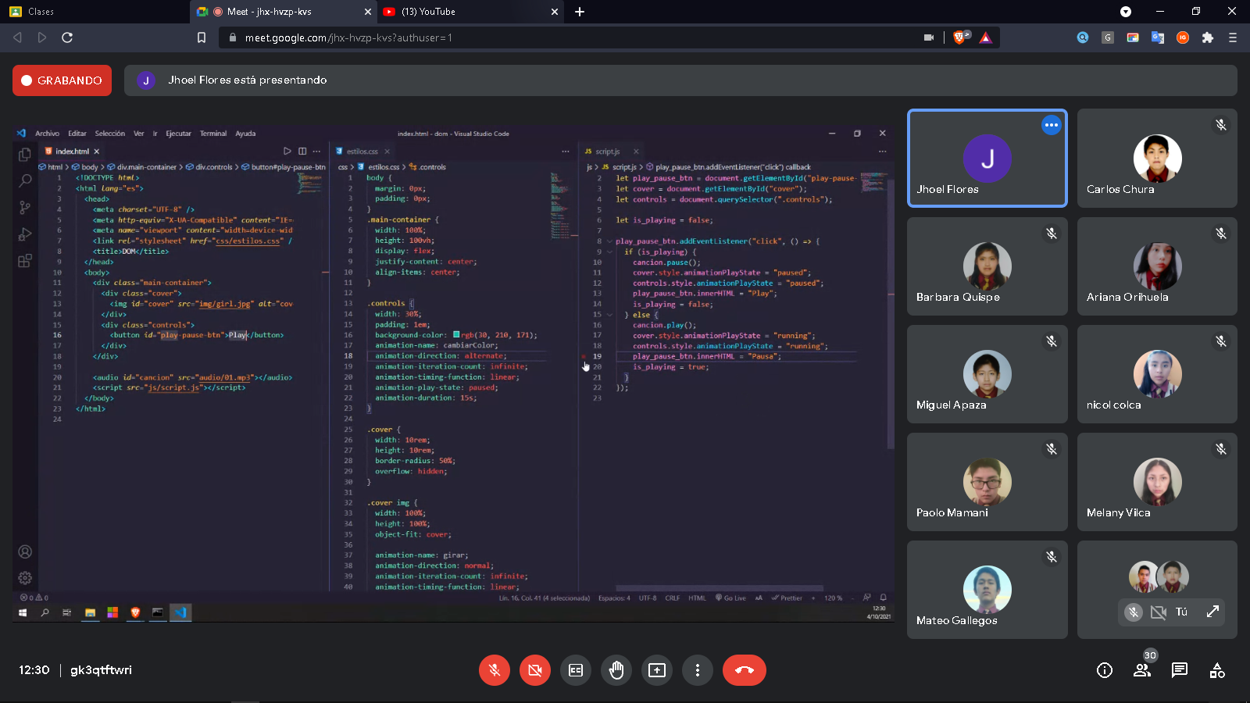 let is_playing = false;

play_pause_btn.addEventListener(*"click"* , () =>{

    if(is_playing){

        cancion.pause();

        cover.style.animationPlayState = *"paused"*;

        controls.style.animationPlayState = *"paused"*;

        play_pause_btn.innerHTML = *"Play"*;

        is_playing = false;

    } else {

        cancion.play();

        cover.girar.animationPlayState = *"running"*;

        controls.style.animationPlayState = *"running"*;

        play_pause_btn.innerHTML = *"Pausa"*

        is_playing = true;

    }

});